**ASSIGNMENT-4**

|  |  |
| --- | --- |
| Team ID | PNT2022TMID07339 |
| Project Name | **Smart Fashion Recommender Application** |
| Maximum Marks | 2 Marks |
| Batch Number | B3-3M5E |

**Question-1:**

Pull an Image from Docker hub and run it in Docker playground.

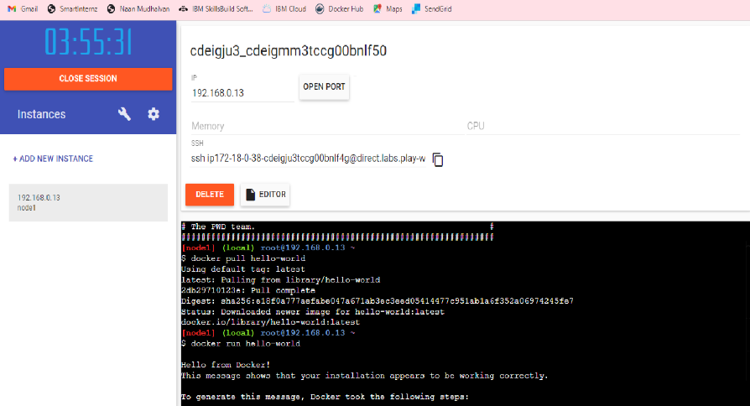

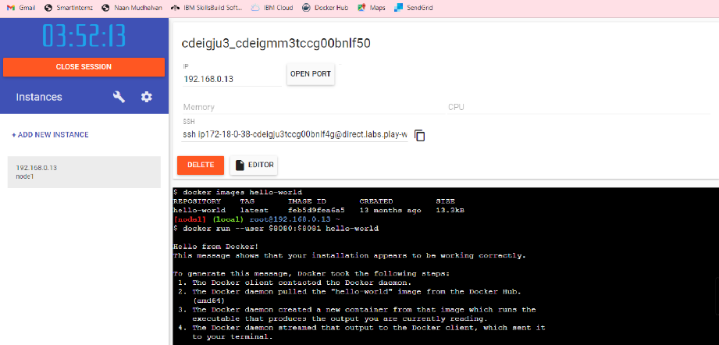

**Question-2:**

Create a Docker file for the job portal application and deploy it in Docker desktop application.

**FROM jobportal1 : latest**

**WORKDIR ~/Desktop/**

**ADD . jobportal1/**

**WORKDIR ~/Desktop/html**

**RUN pip install –r requirements**

**RUN chmod + x app.sh**

**CMD [“/bin/sh”,”app.sh”]**

**Question-3:**

Create an IBM container registry and deploy helloworld app or job portal app.

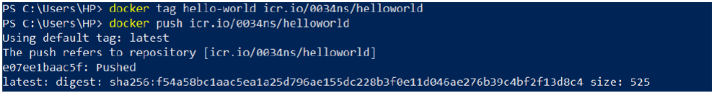

**Question-4:**

Create a Kubernetes cluster in IBM cloud and deploy helloworld image or job portal image and also

expose the same app to run in nodeport.

